# **Complete measurement protocol for precision bike fitting**

For road, gravel, MTB and city bikes

This protocol is designed for a mobile/web application like BikeFIT AI. It is:

• Structured  
• Scientifically grounded  
• Implementation-ready  
• Usable without professional lab equipment

It combines:

* LeMond saddle height method
* Holmes knee angle method
* KOPS principle
* Stack & reach logic
* Modern terrain-specific biomechanics

# **1. Measurement overview**

We divide the input into four blocks:

1. Body dimensions (structural geometry)
2. Functional capacity (flexibility & core stability)
3. Riding ambition & terrain
4. Injury history & constraints

All values must be entered in millimeters unless stated otherwise.

# **2. Body measurements (mandatory + advanced)**

## **A. Total body height**







How to measure:

* Stand barefoot against a wall
* Heels, glutes, upper back touching wall
* Neutral head (Frankfurt plane)
* Place a book flat on head
* Measure floor to mark

Accuracy: ±5 mm

## **B. Inseam length (critical variable)**

Used in:  
LeMond saddle height formula  
Crank length recommendation  
Frame sizing

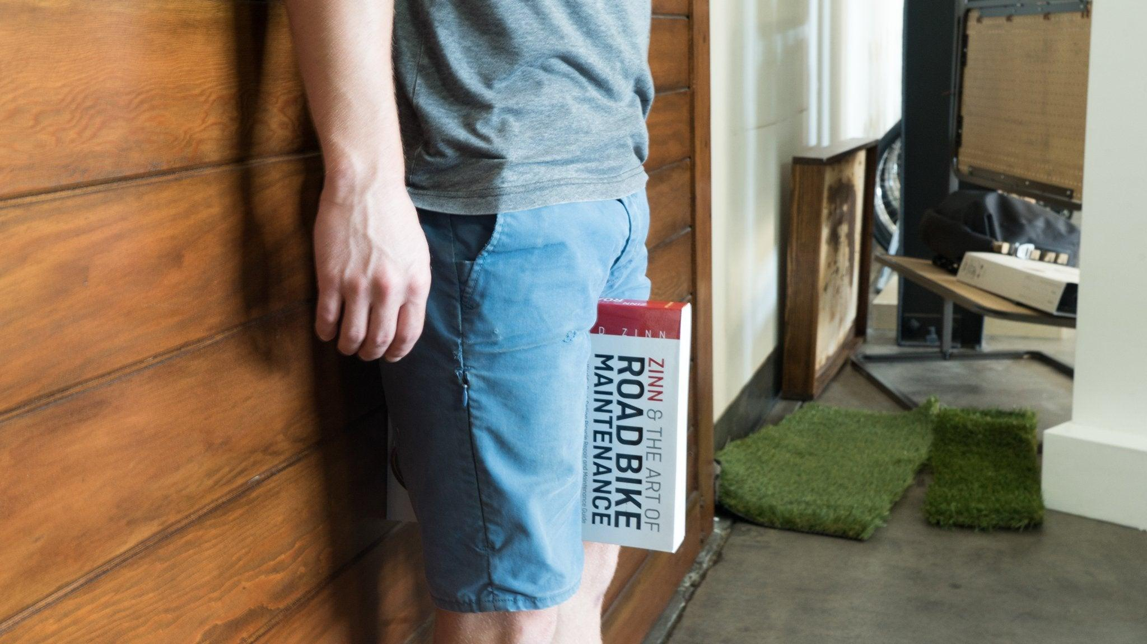



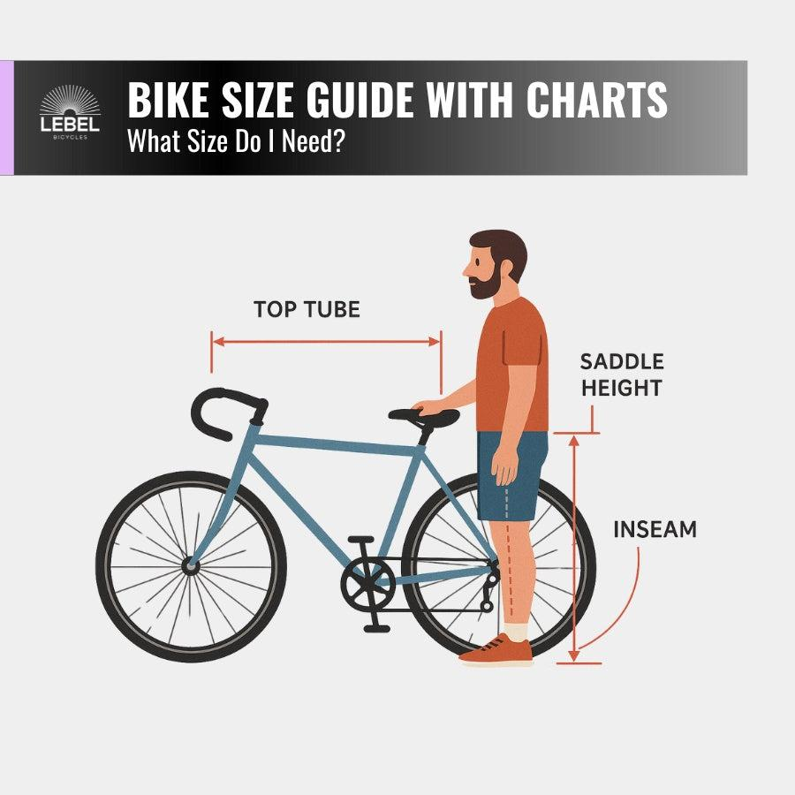

4

How to measure:

* Barefoot
* Back to wall
* Book pressed firmly upward into perineum
* Measure floor to top of book

Accuracy target: ±3 mm

## **C. Torso length (advanced but strongly recommended)**

Used for reach & drop calculation.



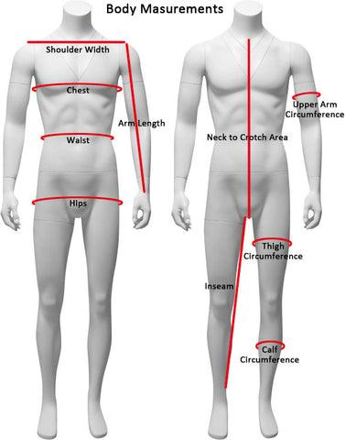

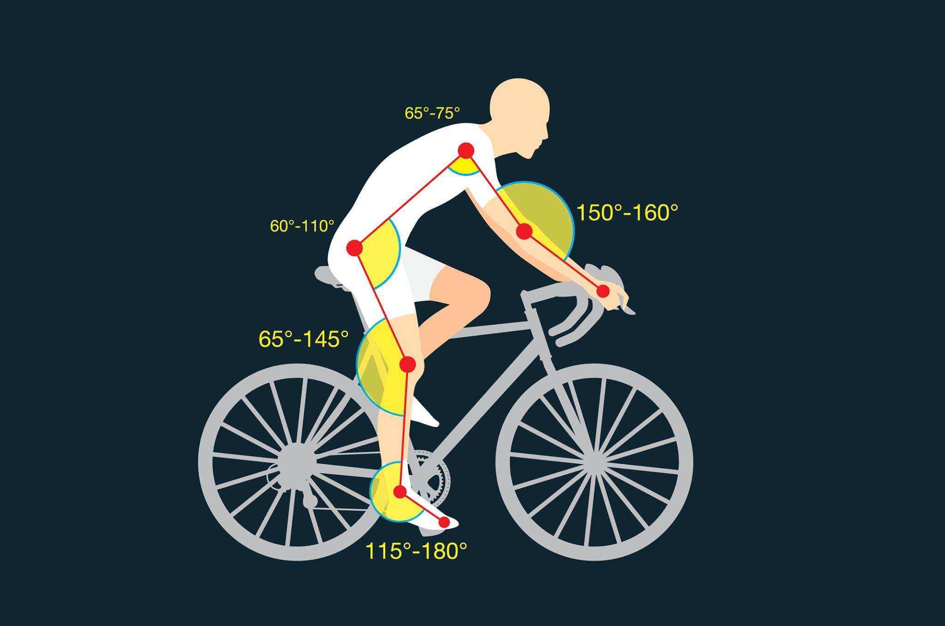

4

Measure:

* Sit upright on hard chair
* Measure from top of sternum notch to book between legs

## **D. Arm length**

Used in stack & reach modeling.

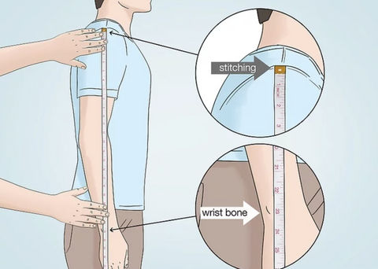



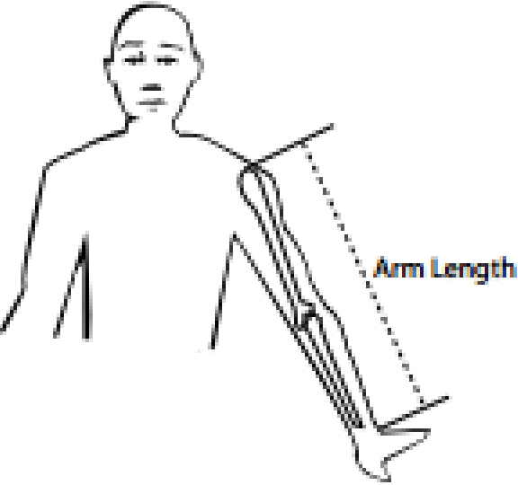

Measure:

* Shoulder joint center to wrist crease
* Arm straight, relaxed

## **E. Femur length (optional but improves saddle setback precision)**



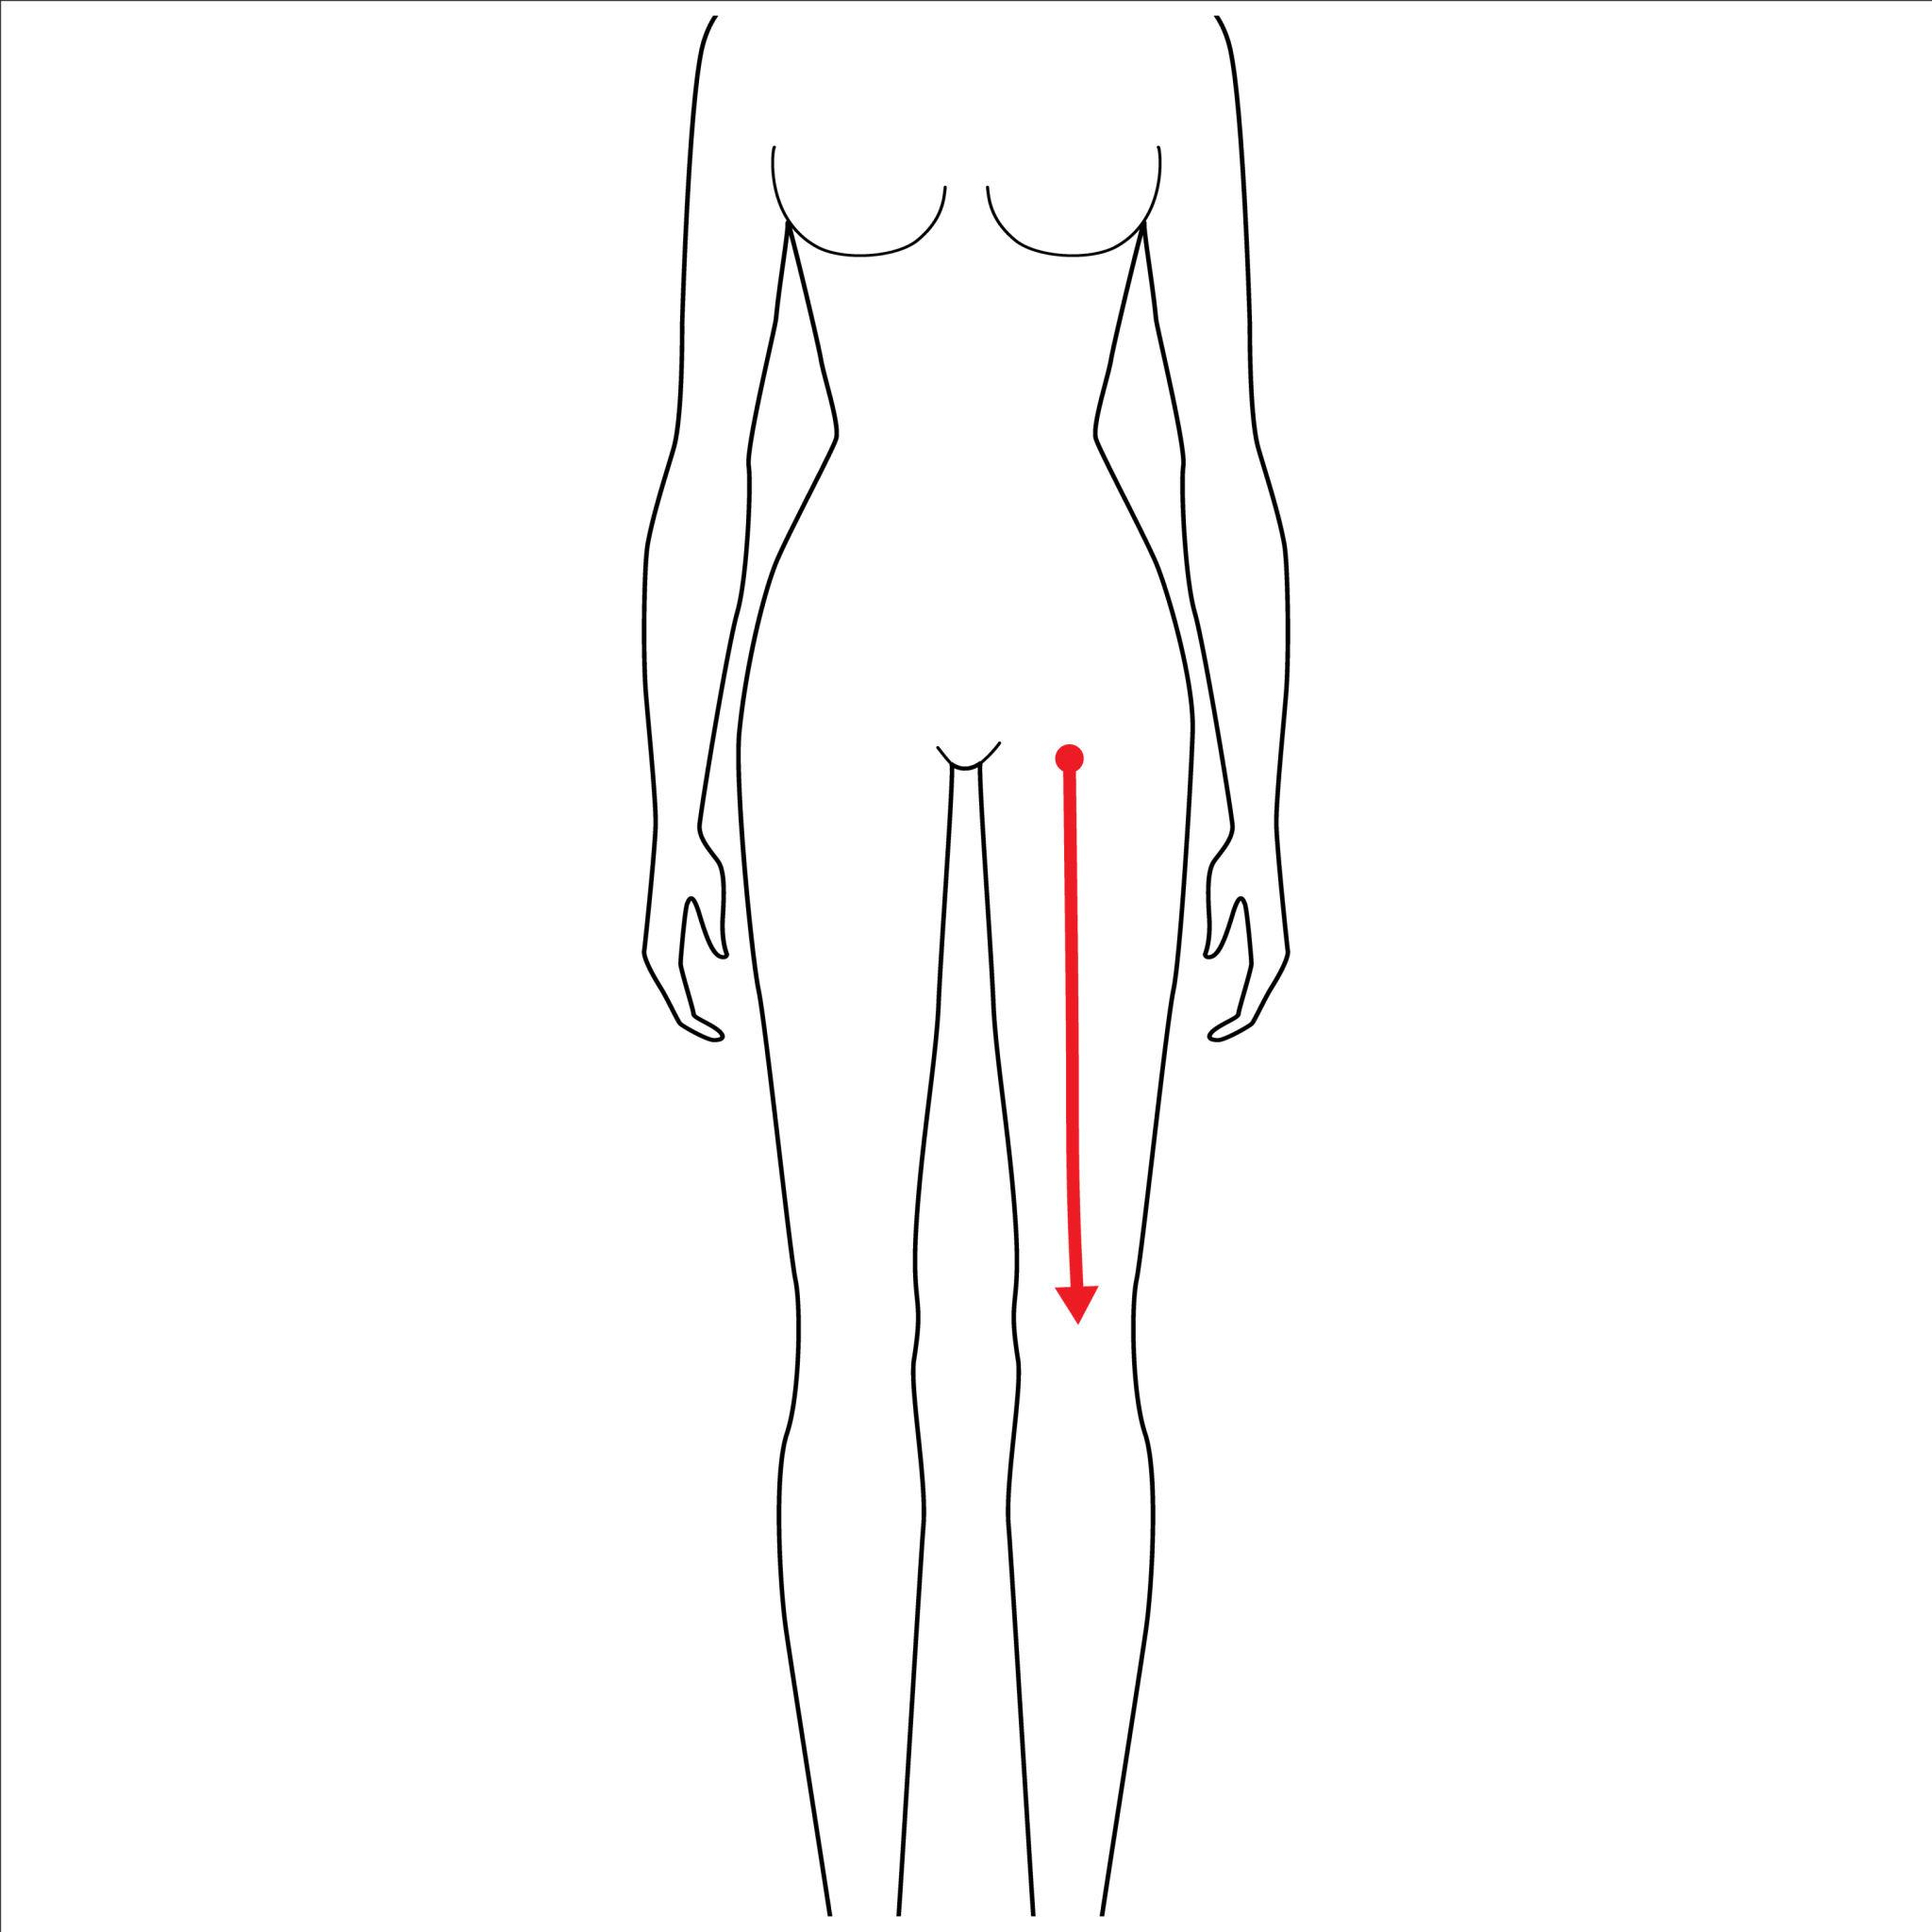

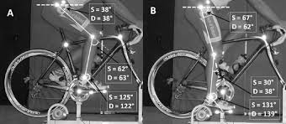

4

Measure:

* Sit with knee at 90°
* Measure hip joint center to knee center

Used for:

* KOPS refinement
* Setback optimization
* MTB position correction

## **F. Shoulder width**

Used for handlebar width recommendation.

Measure:

* Acromion to acromion (bony outer shoulder points)

## **G. Foot length**

Used for cleat position & crank length refinement.

Measure:

* Heel to longest toe

# **3. Functional capacity measurements**

Bike fitting is not only geometry. It is joint range tolerance.

## **A. Hamstring flexibility test**

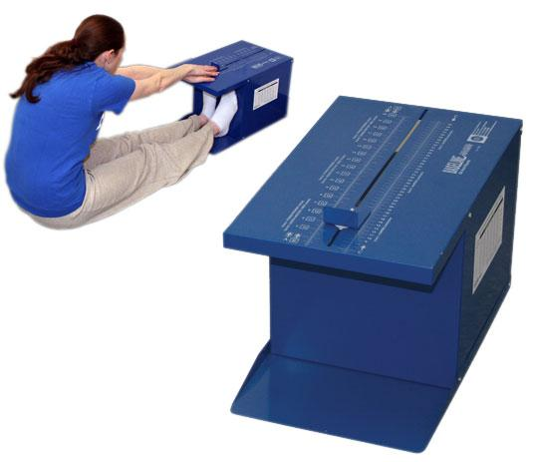

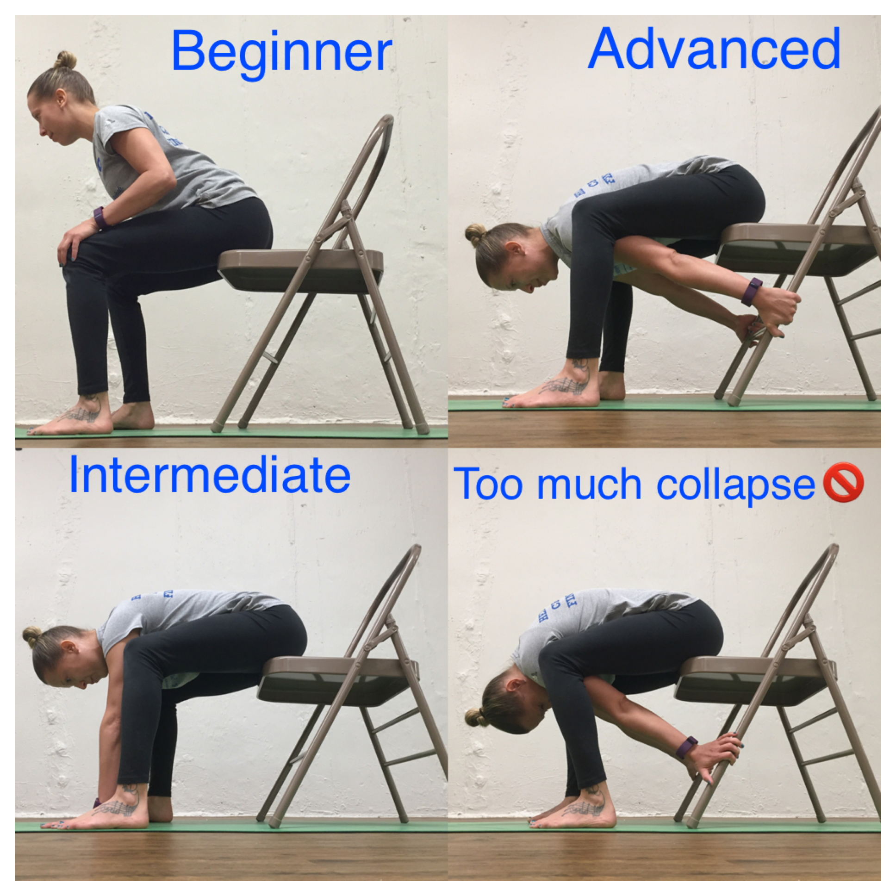

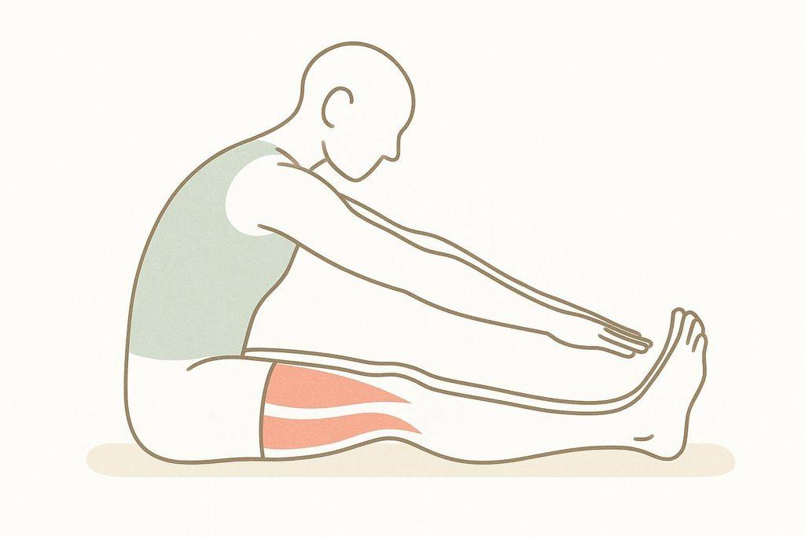

4

Sit-and-reach test:

* Legs straight
* Reach forward
* Measure cm beyond toes

Score (example scale):

* < 0 cm = low flexibility
* 0–10 cm = average
* 10 cm = high

Impact:  
Low flexibility → reduced drop & slightly lower saddle height

## **B. Hip flexor mobility**

Kneeling lunge test:

* Observe pelvic tilt
* If pelvis rotates forward early → limited mobility

Impact:  
Limits aggressive TT or race positions

## **C. Core stability score (self-assessment)**

Plank hold:

* < 45 sec = weak
* 45–90 sec = average
* 90 sec = strong

Impact:  
Low core → less drop, shorter reach

# **4. Ambition & terrain profile**

User must select:

## **Riding type**

* Road performance
* Road endurance
* Gravel
* MTB XC
* MTB Trail/Enduro
* City/commute

## **Weekly volume**

* <3h
* 3–6h
* 6–10h
* 10h

## **Primary goal**

* Comfort
* Balanced
* Speed / race
* Aerodynamics

# **5. Terrain-based biomechanical differences**

## **Road performance**

* Higher saddle precision (Holmes 30–35° knee angle)
* Larger drop
* Longer reach
* Pelvic anterior rotation

Priority: power & aerodynamics

## **Road endurance**

* Slightly lower saddle
* Reduced drop (10–20 mm less)
* Reduced lumbar compression

Priority: long-duration comfort

## **Gravel**

* 5–10 mm lower saddle (stability)
* Shorter reach
* Wider bars
* Slightly rearward weight bias

Priority: control + shock absorption

## **MTB XC**

* Slightly lower saddle
* Reduced setback
* Reduced drop
* More upright

Priority: handling + technical climbing

## **MTB trail/enduro**

* Noticeably shorter reach
* Upright torso
* Lower saddle during descents (dropper)

Priority: descending control

## **City bike**

* Very upright
* Minimal drop
* Lower saddle to improve stop-start control

Priority: safety & low injury risk

# **6. Calculation methods (scientific grounding)**

## **Saddle height**

Primary: LeMond  
Saddle height = inseam × 0.883

Refined by:

* Flexibility score
* Riding style
* Holmes knee angle target (30–35° at bottom stroke)

Adjustment rules:

* Low flexibility → −3 to −7 mm
* High performance rider → +2 to +4 mm

## **Saddle setback**

Primary:

* KOPS reference
* Femur length correction

Long femur → increase setback  
Short femur → decrease setback

MTB → slightly less setback for maneuverability

## **Handlebar drop**

Based on:

* Torso + arm length
* Flexibility
* Core stability
* Riding ambition

Typical ranges:

Road race: 6–12 cm  
Endurance: 4–8 cm  
Gravel: 3–6 cm  
MTB: 0–4 cm  
City: negative drop (bar above saddle)

## **Crank length**

General model:

Inseam < 75 cm → 165 mm  
75–82 cm → 170 mm  
82–88 cm → 172.5 mm

88 cm → 175 mm

High cadence rider → shorter crank  
TT → often shorter crank to allow hip closure

# **7. Injury risk flags**

The system must warn if:

• Saddle too high → hamstring overload, posterior knee pain  
• Saddle too low → anterior knee pain  
• Too much drop + low flexibility → lumbar strain  
• Excessive reach → shoulder/neck compression  
• Excess setback + weak core → pelvic rocking

# **8. Measurement quality validation logic**

The app should detect unrealistic combinations:

Example rules:

* Inseam cannot be > 53% of body height
* Torso + inseam should approximate total height
* Femur typically 24–27% of height

If deviation >10%, prompt re-measurement.

# **9. Output must include**

1. Exact millimeter values
2. Saddle height reference point (BB center to saddle top)
3. Setback measurement method (plumb line)
4. Drop measurement method (saddle to bar top vertical)
5. Step-by-step adjustment order:
   1. Saddle height
   2. Saddle setback
   3. Cleats
   4. Stem length
   5. Drop

# **10. Minimal measurement set (for MVP)**

If user skips advanced inputs, use:

Required:

* Height
* Inseam
* Riding type
* Flexibility score
* Goal

Advanced improves precision but is optional.